HackerEarth - Digit Sum
Code:
#include <stdio.h>

int main() {
int T;
scanf("%d", &T);

while (T > 0) {
long long N;
scanf("%lld", &N);

int lastDigit = N % 10;
int firstDigit = N;
while (firstDigit >= 10) {
firstDigit = firstDigit / 10;
}

printf("%d\n", firstDigit + lastDigit);
T--;
}

return 0;
}

Screenshot:
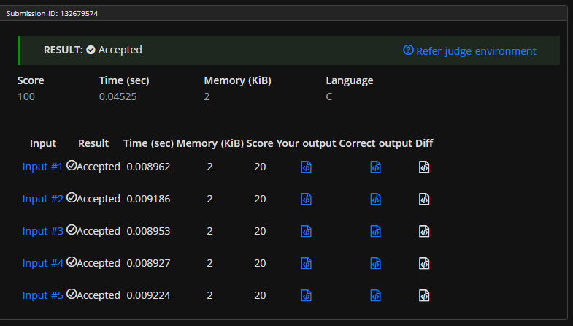

Link:
https://www.hackerearth.com/problem/algorithm/digit-sum-4/

